Name: Jay Rajesh Umap

Roll No.: 2205010

Enrollment No.: MITU20BTIT0029

Class: TY IT

Div.: CORE

1. Create a trigger to Update no_of copies after insert in transaction

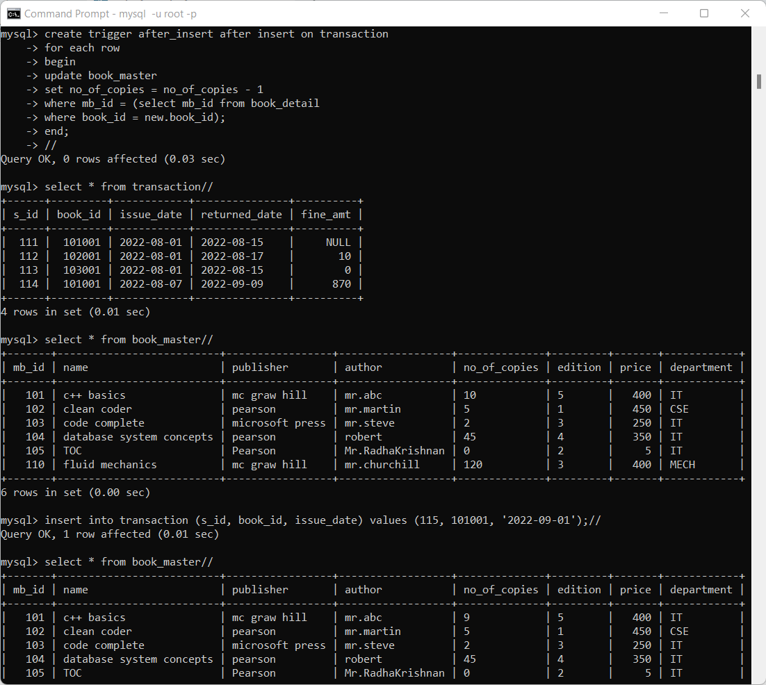

2. Create a trigger to update no_of_copies when books are returned.

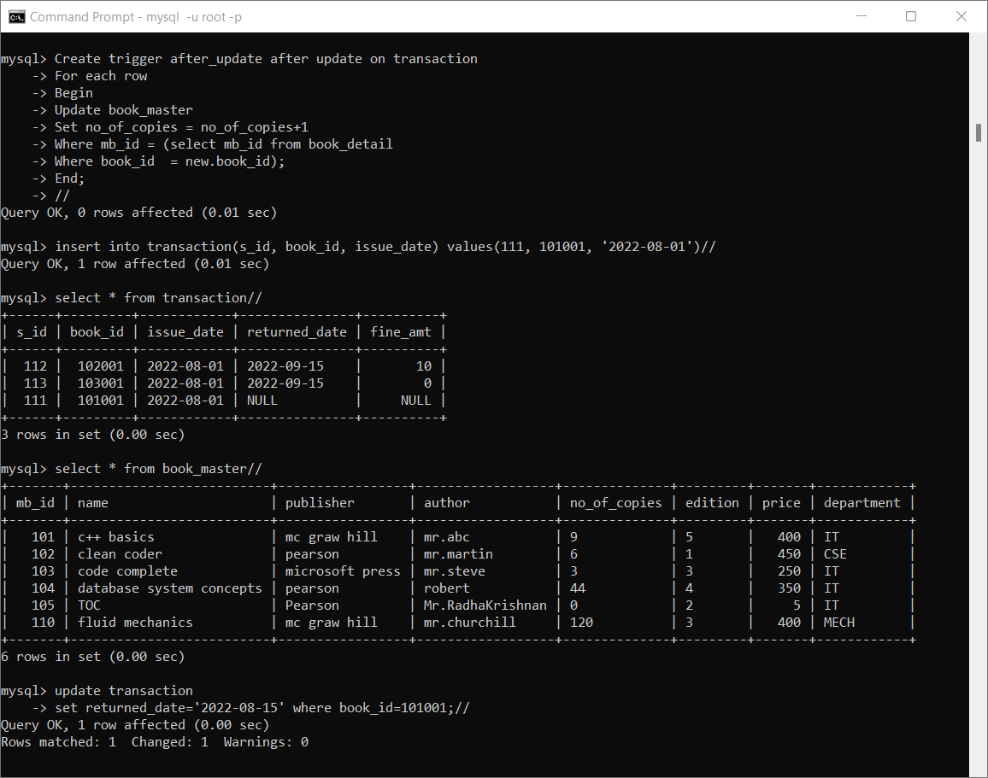

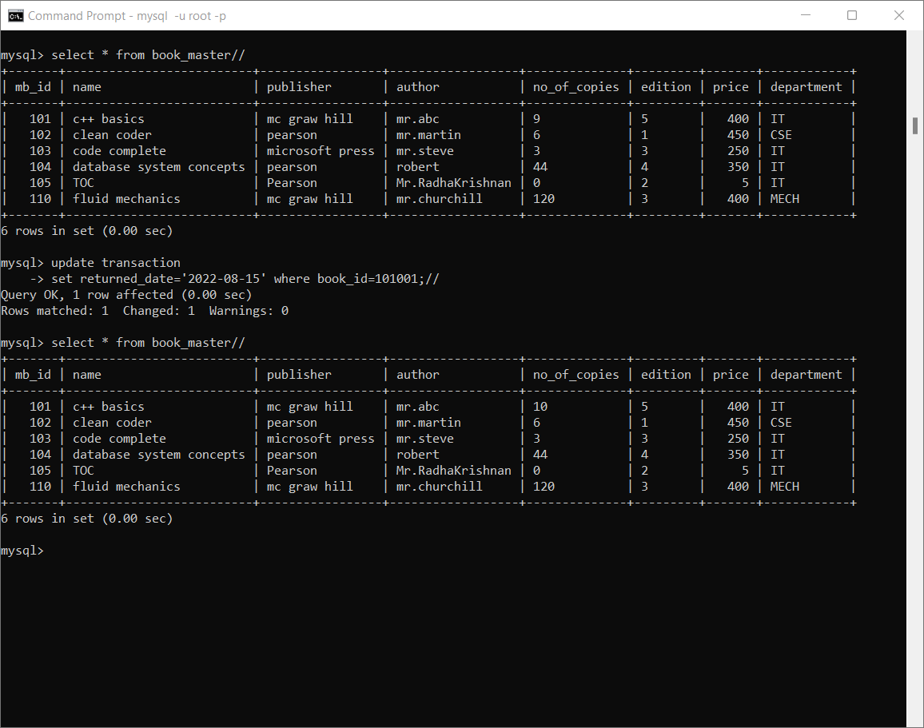

3. Create a trigger to update no_of_copies when book is deleted.

